**GST101: SOUND**

**SPEECH WORK**

**PRODUCTION OF SPEECH SOUNDS**

Speech is a continuous flow of sounds. The production of speech sound starts from the brain and not the lungs. The part of the brain that coordinates speech sends the message to the other parts of the body used for speech production. After this mental operation comes the physical production of sounds. The speech sounds are going to be studied from the articulatory point of view.

Thus, there are three stages in the production of speech sounds:

1. **The psychological stage** which is the stage of conception and it involves the brain
2. **The physiological stage**, also called the generation stage. It is the stage at which the various organs of speech are instructed by the brain to articulate a sound.
3. **Physical stage** is the stage of transmission. It is also the stage of production and perception. At this stage, the brain must have instructed the organs of speech which will in turn articulate the sound and the sound will be perceived by hearer(s).

Speech sounds are initiated by the expulsion of air from the lungs. This is called the air stream mechanism. English sounds are produced with an outward flow of air from the lungs. This is called the **pulmonic egressive air stream**. The voicing or phonation of sounds occurs in the larynx.

**ORGANS OF SPEECH PRODUCTION**

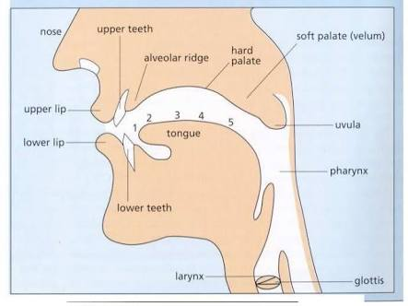

Organs of speech production are:

1. The two lips: These are important in speech. They can be pressed together (p, b), brought into contact with the teeth (f, v) or rounded to produce the lip shape for vowels. These sounds are called bilabial or labiodental
2. The teeth (upper and lower): These are usually used to produce sounds. When thwy come in contact with the tongue, they produce dental sounds (ᶿ,ᶞ ); and when they come in contact with the lips, they produce labiodental sounds.
3. Alveolar ridge: Sounds from this place are called alveolar sounds
4. Hard palate: sounds from this place are called palatal, and sometimes palate-alveolar sounds
5. Soft palate: the sounds here are called the velar sound.
6. Tongue: This is a mobile articulator because it is free to move. It can take different shapes during the production of speech sounds. It can be divided into 5 parts: 1. Tip; 2. Blade; 3. Front; 4. Centre; 5. Back.
7. The larynx: this houses the vocal cords
8. Glottis: this organ houses the vocal cords which are the two elastic tissues involved in the production of voice in sounds. The glottis can take different shape during sound production. It can be creaky, voiceless or voiced.
9. Nose: the air from the lungs is released through the nose in the production of nasal sounds.

**CLASSIFICATION OF SPEECH SOUNDS**

There are two broad types of speech sounds: consonants and vowels. Consonant sounds are the sounds produced with the total blockage of the airstream at some point in the vocal tract. There are 24 consonant sounds in English language and they are not to be confused with the English alphabet. These consonants are:

/p/- plate, purple, place, pin, clap, tadpole

/b/- badge, cab, born, baby, combine, burst

/t/- tap, table, total, teeth, feet, walked, laughed

/d/- bagged, dog, dungeon, burden, boredom

/k/- kettle, kite, chasm, cake, campaign, create

/g/- gate, goat, giggle, gossip, bag

/Ө/- thought, strength, bath, cloth, breath

/ð/- bathe, clothe, breathe, the, therefore, other

/f/- fan, for, faith, baffle, stuff,

/v/- van, vest, veal, vocal, vacant, glove,

/s/- seize, cease, peace, piece, sing, son,

/z/-zest, crazy, zoo, please, size, boys

/ʃ/- chasse, machine, share, champagne, bush, pressure, education

/ʒ/- occasion, measure, treasure, pleasure, confusion

/tʃ/- church, chain, chair, choice, clutch

/ʤ/- judge, joy, jay-walker, just,

/h/- house, hotel, hostel, hostile, hostess, hand, hole, head, half, habit

/r/- river, run, race, rustic, eraser, dresser

/w/- wink, work, walk, waiter,

/j/- new, queue, cue, occupation, confusion

/l/- long, pebble, light, gale, glory, ball

/m/- female, man, male, master, climb, comb, plumber, bomb,

/n/- know, knife, night, naughty, tone, tarnish

/ ŋ/- bang, clang, bank, bangle, king, thank

**CONSONANT CHART**

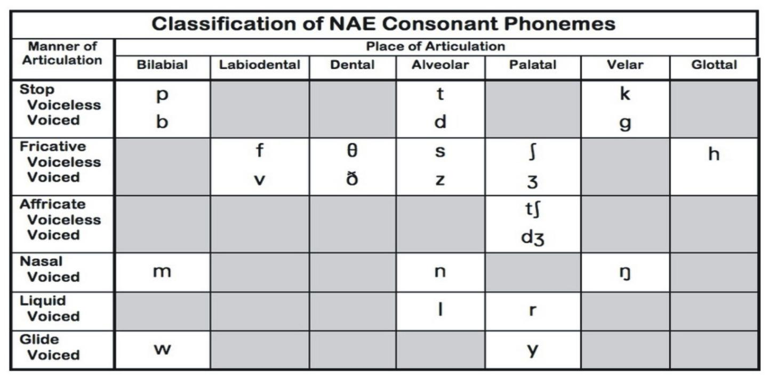

THE VOWEL

There are 20 vowels in all and they are of two types, namely: the monophthong and the diphthong. Monophthongs have only one vowel sound throughout the pronunciation while diphthongs have two sounds in their pronunciation. There are 12 monophthongs while there are 8 diphthongs.

VOWEL CHART

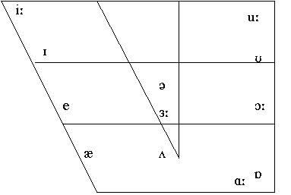

/ɪ/- pit, village, hamlet

/iː/- see, beat

/ʊ/- good, wood, would, could, should, foot, put

/uː/- food, stooge, tooth,

/e/- egg, pet

/ə/- away, father

/ɜː/- birth, burn, word

/ʌ/- enough, cut, son,

/ɒ/- on, pot,

/ɔː/- taut, caught, torn, thorn, born

/æ/- cat, mat, man

/ɑː/- father, park

The diphthongs

/ɪə/- here, hear, fear

/eɪ/- gate, eight, pray

/ʊə/- cure, pour, tour

/ɔɪ/- boy, moisture

/əʊ/- know, nose, no

/eə/- there, heir, air, fare, fair

/aɪ/- my, buy

/aʊ/- now, cow

Triphthongs

/aɪə/- fire, trial

/aʊə/- flour, sour

/ɔɪə/- buoyant,

Class practice

What consonant/vowel sounds are in the following underlined sounds?

Quay, knife, clear, mortgage, sour, chasm, education, yes, join, river, towel